Mod 6 Project

Chris Schmidlin

Rasmussen College

Author Note

This paper is being submitted on September 12, 2019, for Dr. Mortoza Abdullah’s COP1350C C++ Programming course.

Mod 6 Project

Decisions that will need to be implemented into a contact manager

* Menu system

1. Ask to input the data
2. Sort ascending order
3. Sort descending
4. Print all the data
5. Search
6. Exit

If 1 is chosen:

Loop through asking for name and phone number

If 2 is chosen:

Sort the data inputted in ascending order

If 3 is chosen:

Sort the data inputted in descending order

If 4 is chosen:

Print the sorted or unsorted data

If 5 is chosen:

Search for the inputted name

If 6 is chosen:

Exit the program

* Sorting the data

Go through a bubble sort for both ascending and descending order

* Print the data

Cycle through the arrays printing each element

* Searching the data for a particular name

Take the string given by the user and match it each element until match is found

* Exit

Exit the program

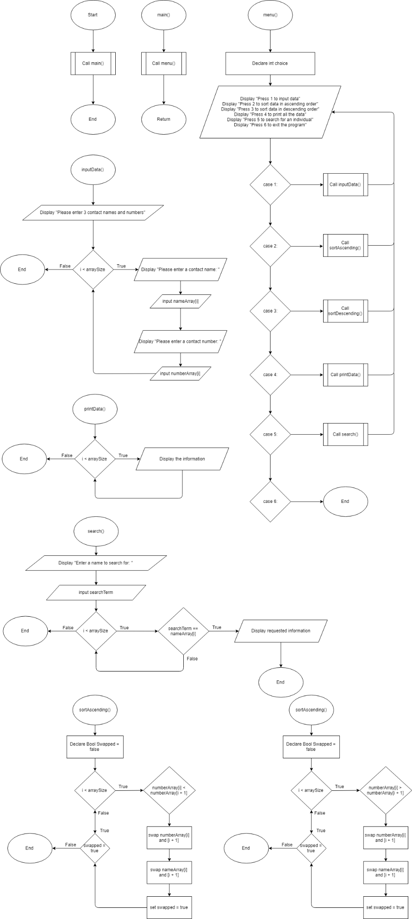

// Simple Contact Manager program

#include <iostream>

#include <string>

#include <cstdlib>

#include <iomanip>

using namespace std;

int arraySize = 5;

string nameArray[5] = {""};

string numberArray[5] = {""};

string searchTerm = "";

bool swapped;

//Get data algorithm

void inputData() {

cout <<"Please enter 3 contact names and numbers. "<<endl;

for (int i = 0; i < arraySize; i++) {

cout<<"Please enter a contact name: ";

cin>>nameArray[i];

cout<<"Please enter a contact number: ";

cin>>numberArray[i];

}

}

//Print data algorithm

void printData() {

cout<<endl;

for (int i = 0; i < arraySize; i++){

cout<<setw(2)<< i+1<<"."<<" Name: "<<setw(20)<<nameArray[i]<<" | "<<" Number: "<<setw(15)<<numberArray[i]<<endl;

}

}

//Ascending sort algorithm

void sortAscending() {

do {

swapped = false;

for ( int i = 0; i < arraySize - 1; i++ ){

if ( numberArray[i] > numberArray[i + 1]){

swap(numberArray[i], numberArray[i + 1]);

swap(nameArray[i], nameArray[i + 1]);

swapped = true;

}

}

} while (swapped);

}

//Descending sort algorithm

void sortDescending() {

do {

swapped = false;

for ( int i = 0; i < arraySize - 1; i++ ){

if ( numberArray[i] < numberArray[i + 1]){

swap(numberArray[i], numberArray[i + 1]);

swap(nameArray[i], nameArray[i + 1]);

swapped = true;

}

}

} while (swapped);

}

//Search algorithm

void search() {

cout << "Enter a name to search for: ";

cin >> searchTerm;

for ( int i = 0; i < arraySize - 1; i++ ){

if ( searchTerm == nameArray[i]){

cout<<setw(2)<< i+1<<"."<<" Name: "<<setw(20)<<nameArray[i]<<" | "<<" Number: "<<setw(15)<<numberArray[i]<<endl;

}

}

}

//Menu algorithm

int menu(){

int choice;

while(1){

cout << "\n\nPress 1 to input data" << endl;

cout << "Press 2 to sort data in ascending order" << endl;

cout << "Press 3 to sort data in descending order" << endl;

cout << "Press 4 to print all the data" << endl;

cout << "Press 5 to search for an individual" << endl;

cout << "Press 6 to end the program" << endl;

cin >> choice;

cout << "\n\n" << endl;

switch (choice){

case 1:

cin.ignore();

inputData();

break;

case 2:

sortAscending();

case 3:

sortDescending();

case 4:

printData();

case 5:

search();

case 6:

return 0;

break;

default:

;

}

}

}

int main(){

menu();

return 0;

}